Screenshots for Supervisor View:

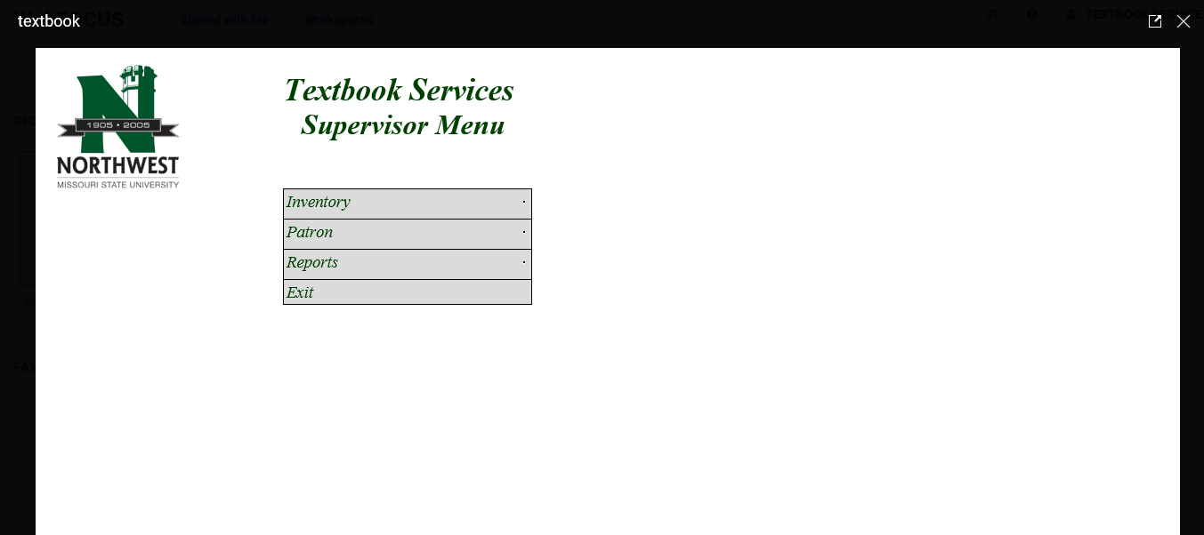

Submenu in Inventory

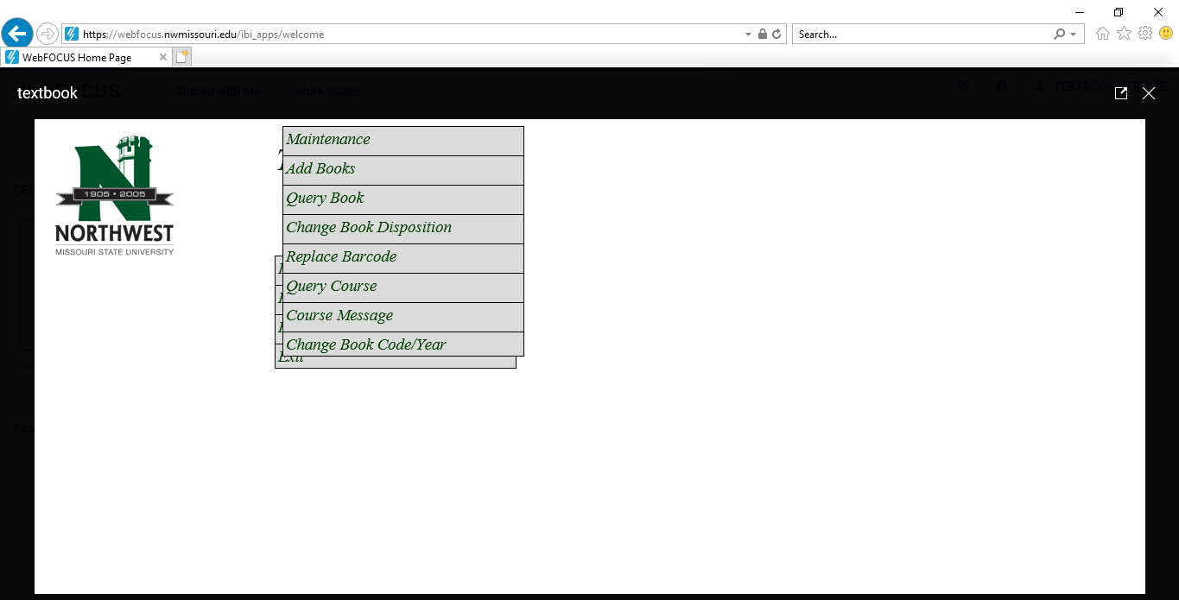

1. Maintenance Form View:

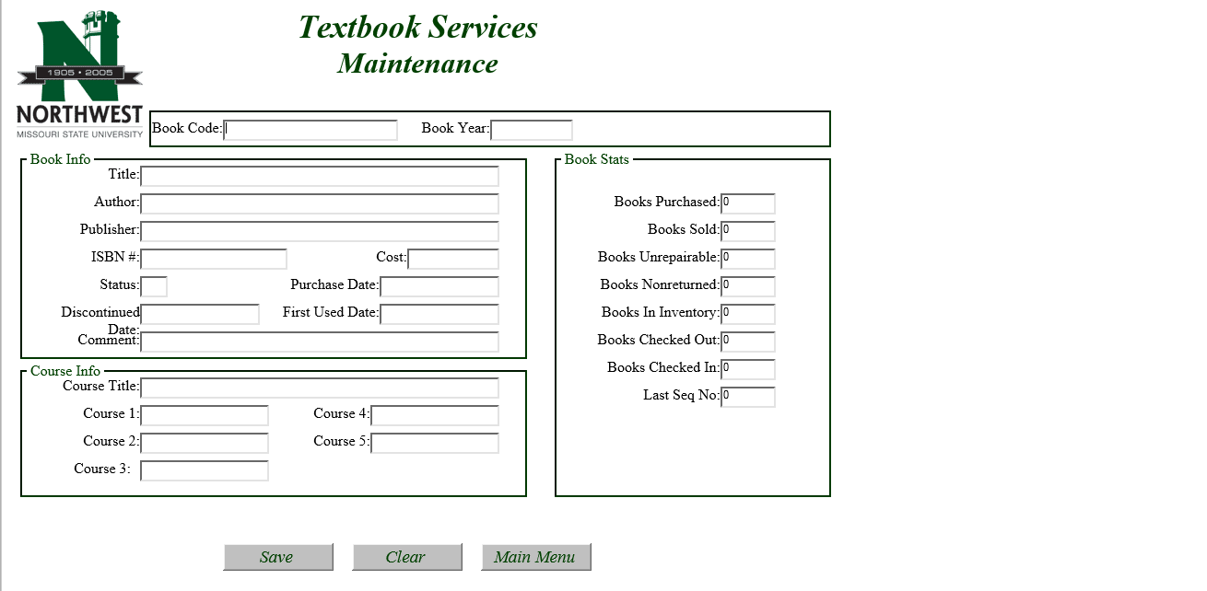

1. Add Books Form View:

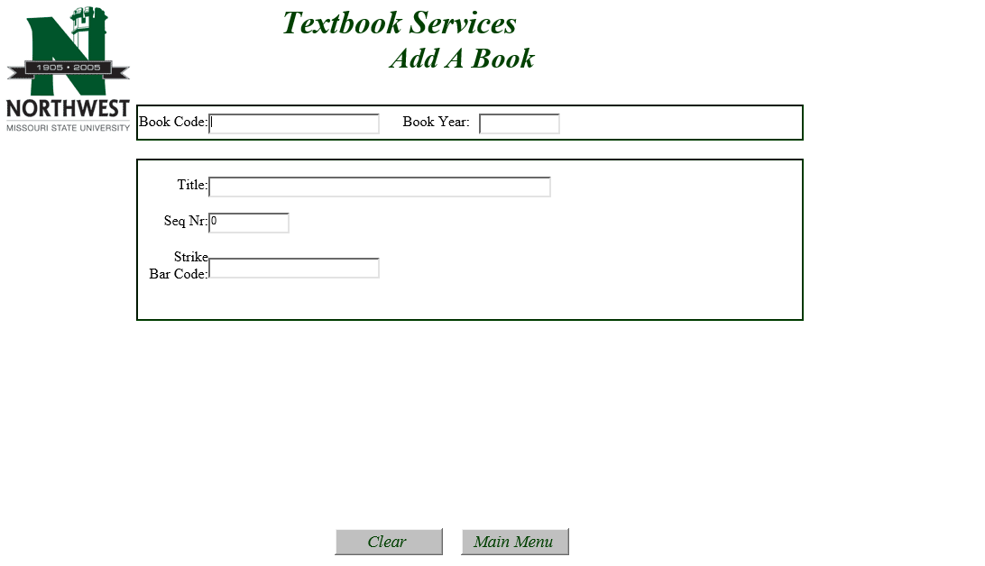

1. Query Book Form:

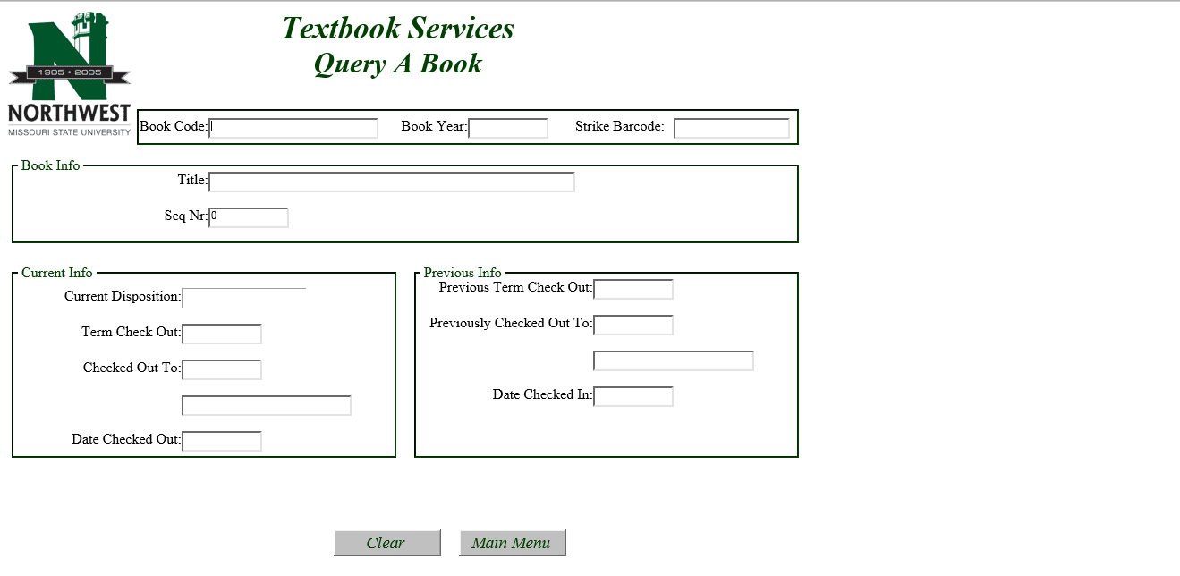

1. Change Book Disposition Form View:

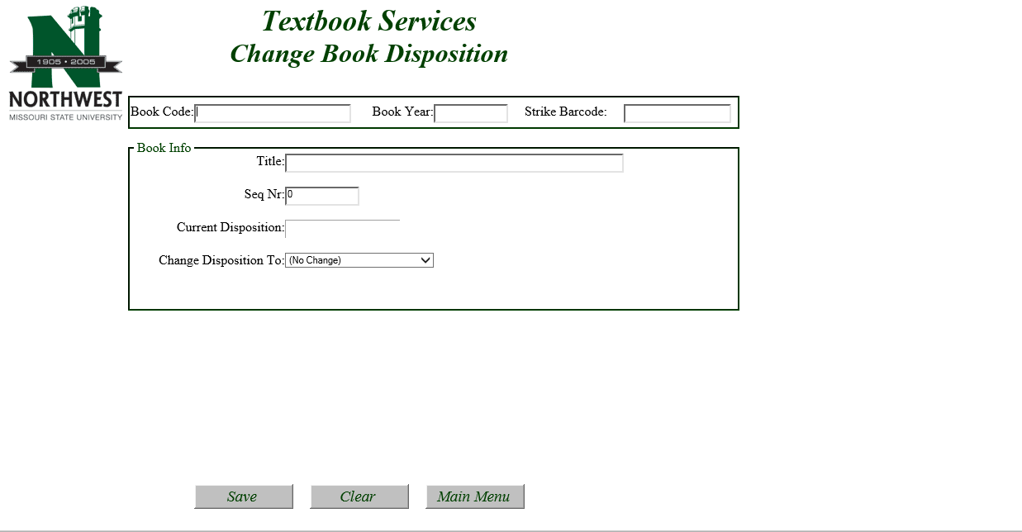

1. Replace Bar Code Form View

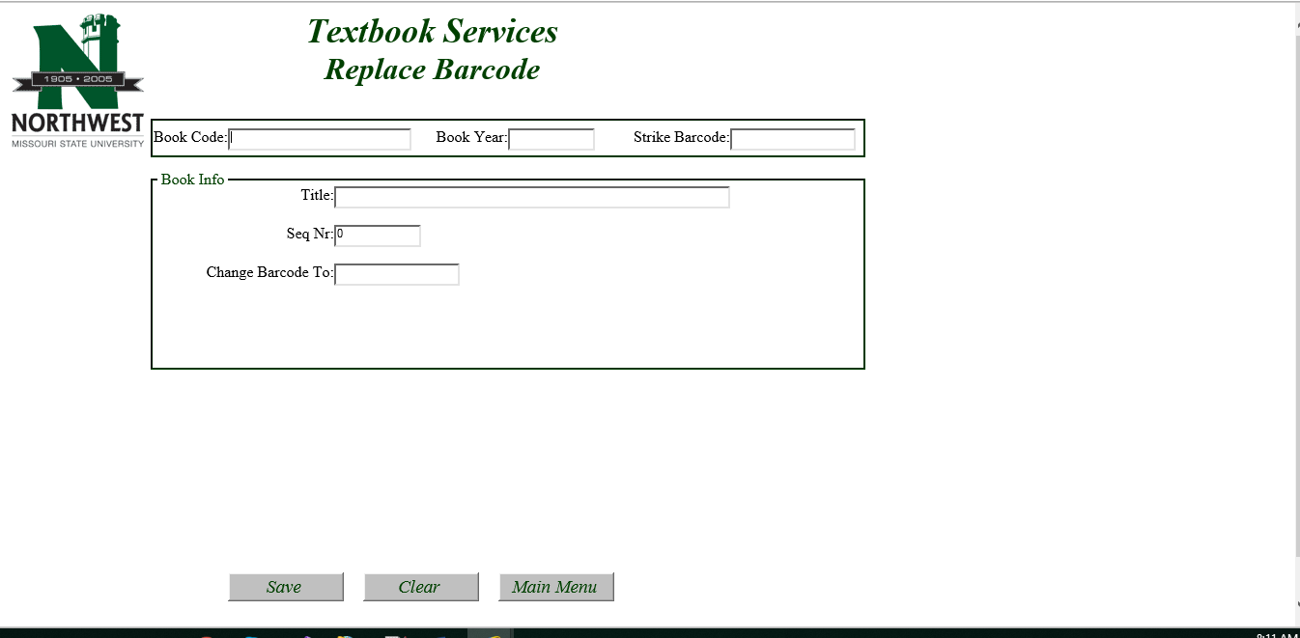

1. Query a Course Form View

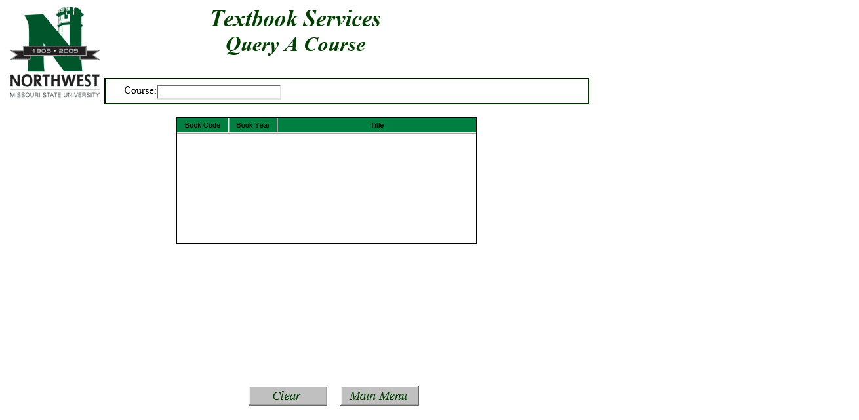

1. Course Message Form View:

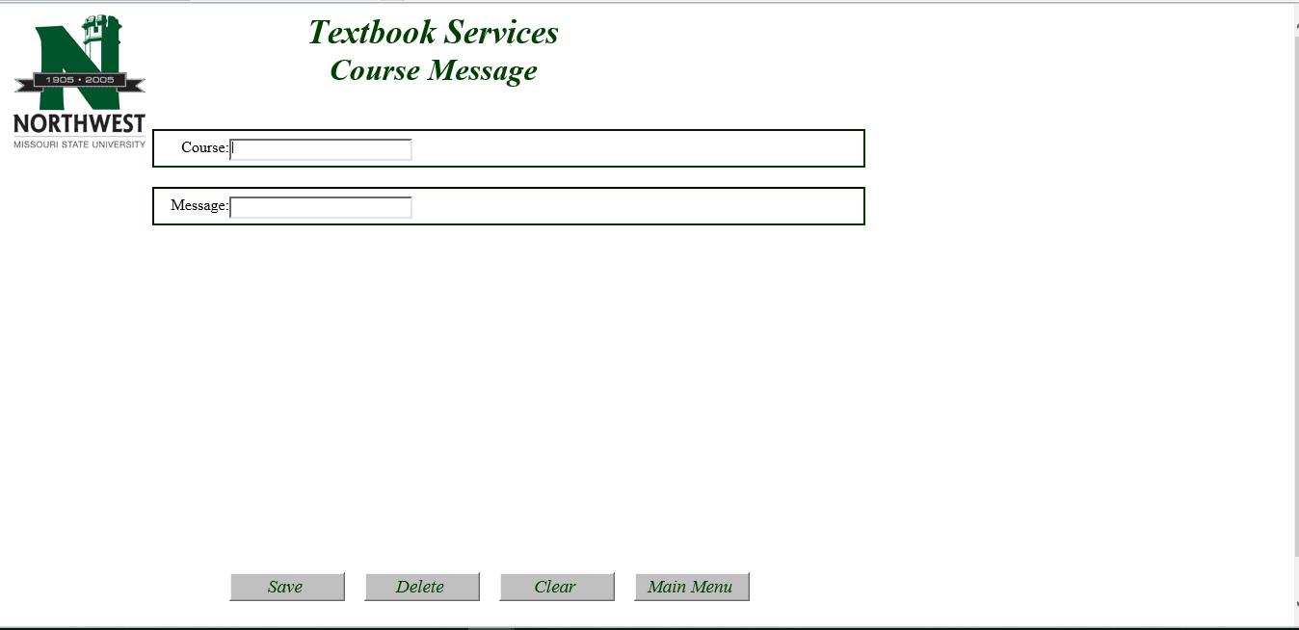

1. Change Book Code/Year Form View

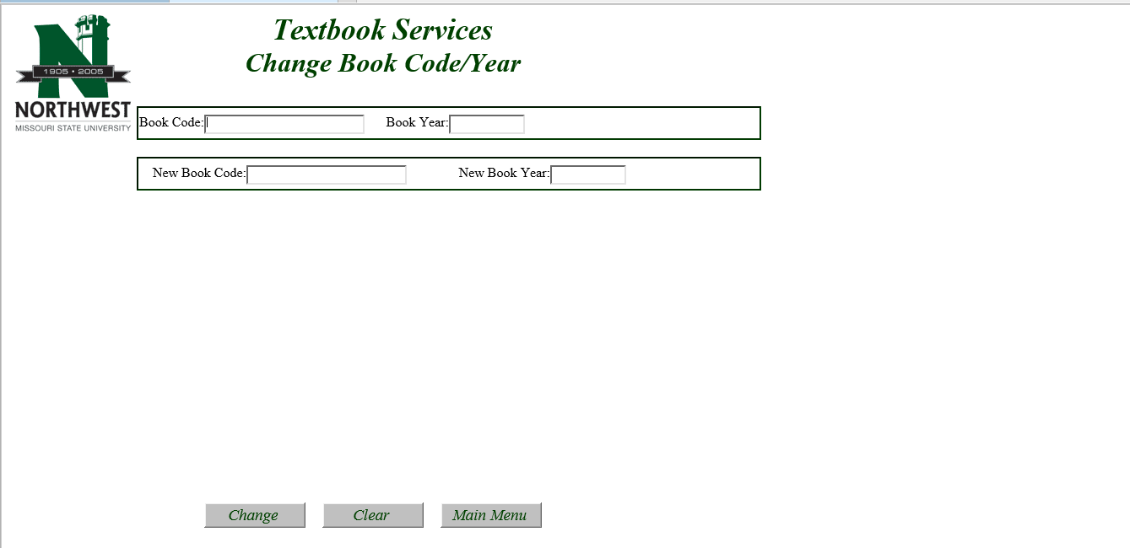

**SubMenu for Patrons:**

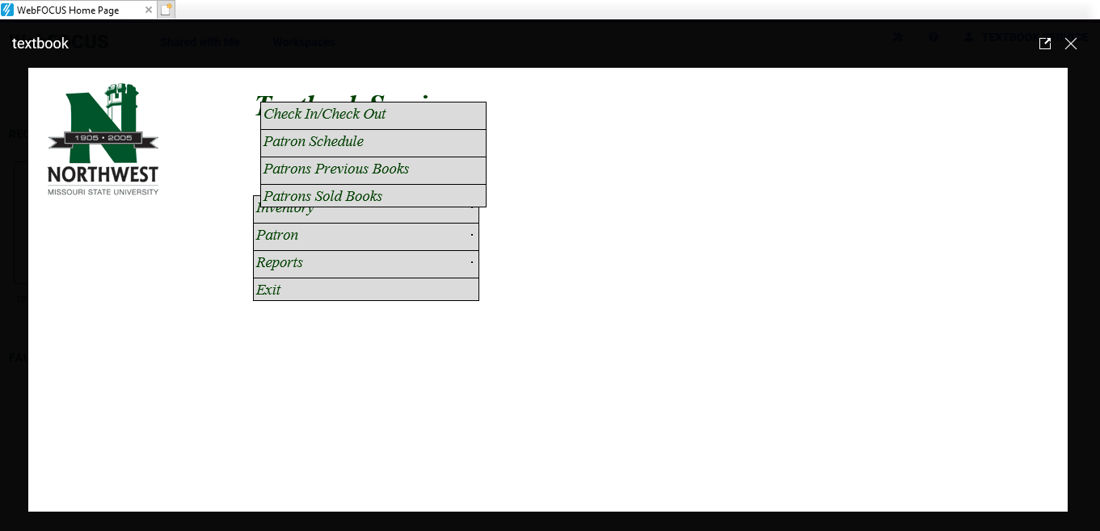

1. Check In/Out Form View

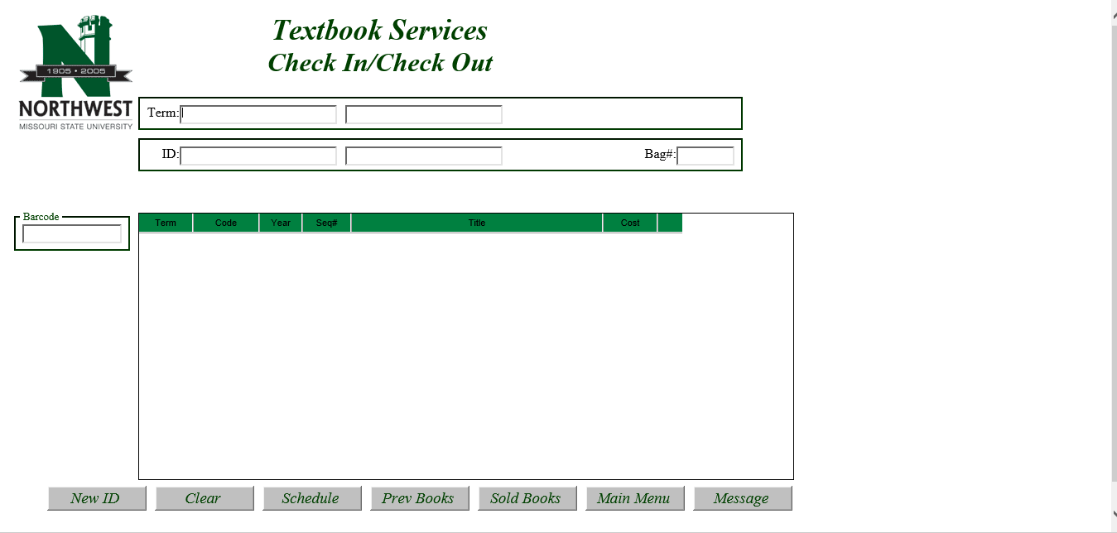

1. Patron Schedule Form View

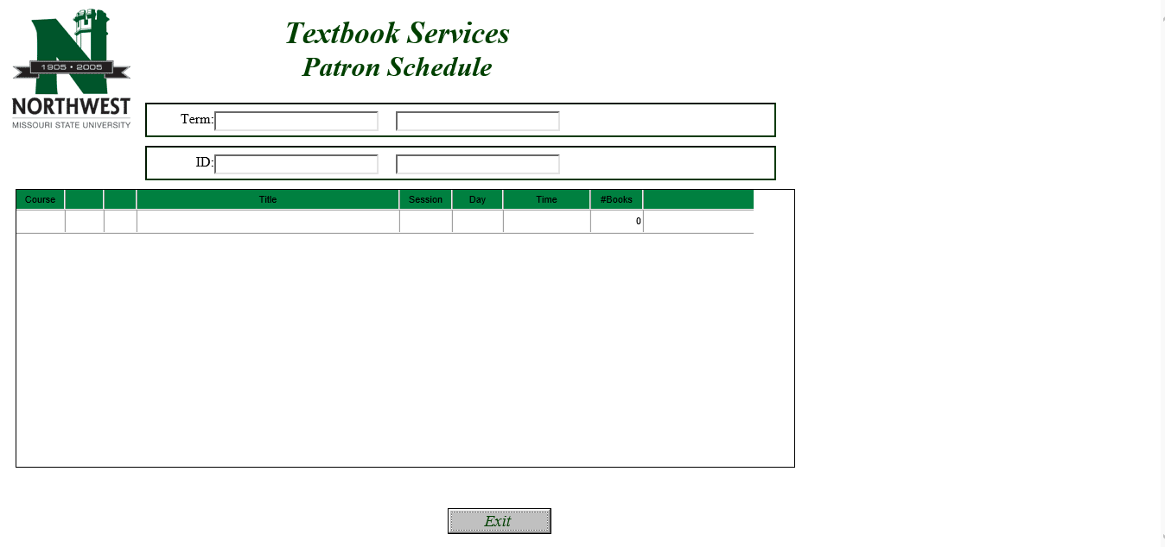

1. Patron Previous Books Fom View

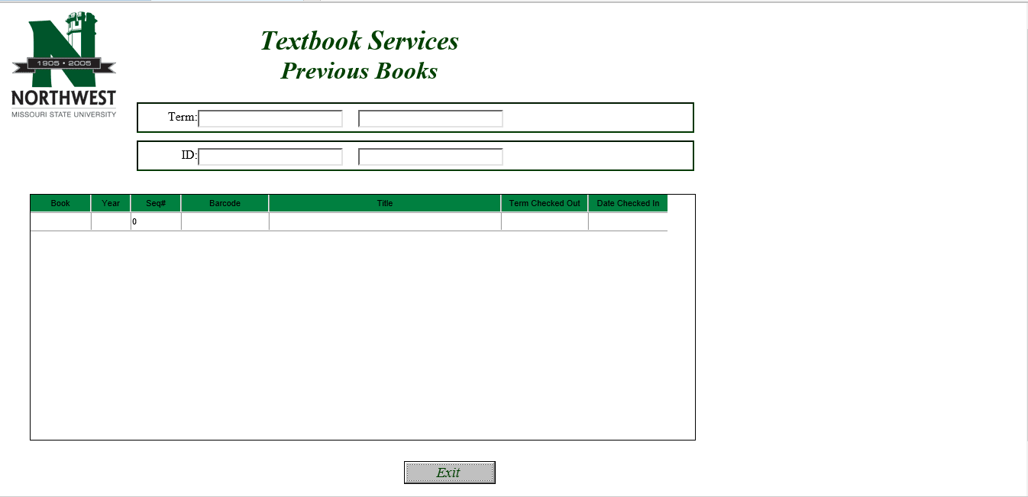

1. Patron Sold Books Form View

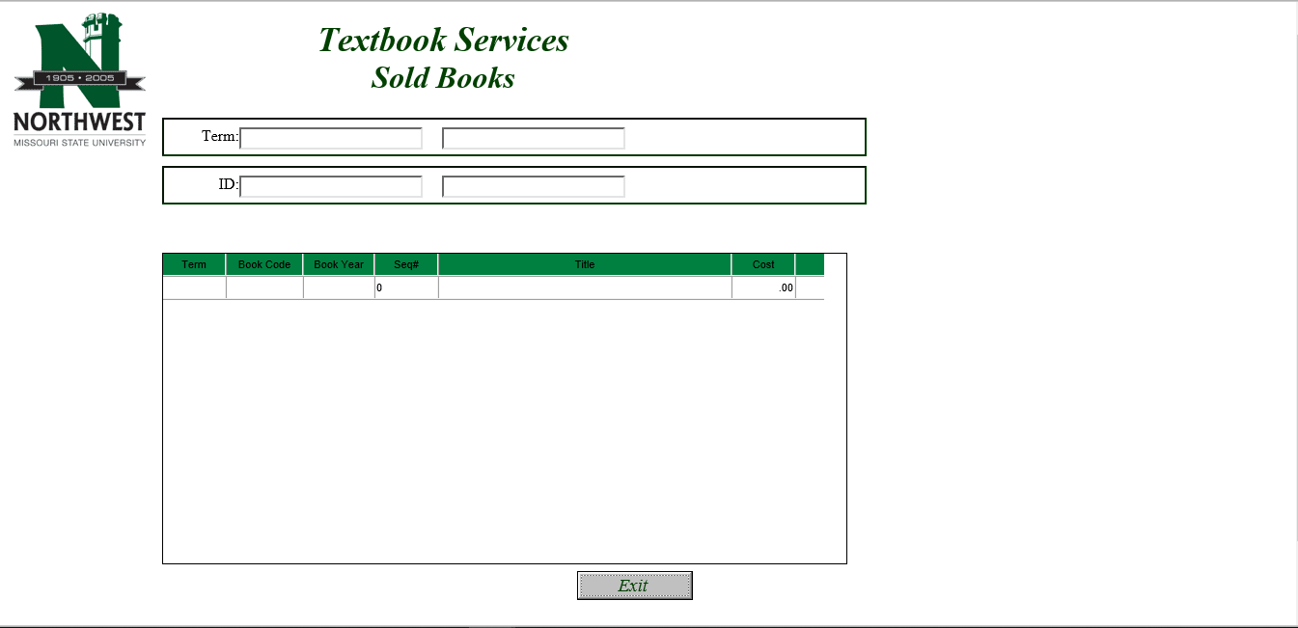

Screenshots for Student Employee View:

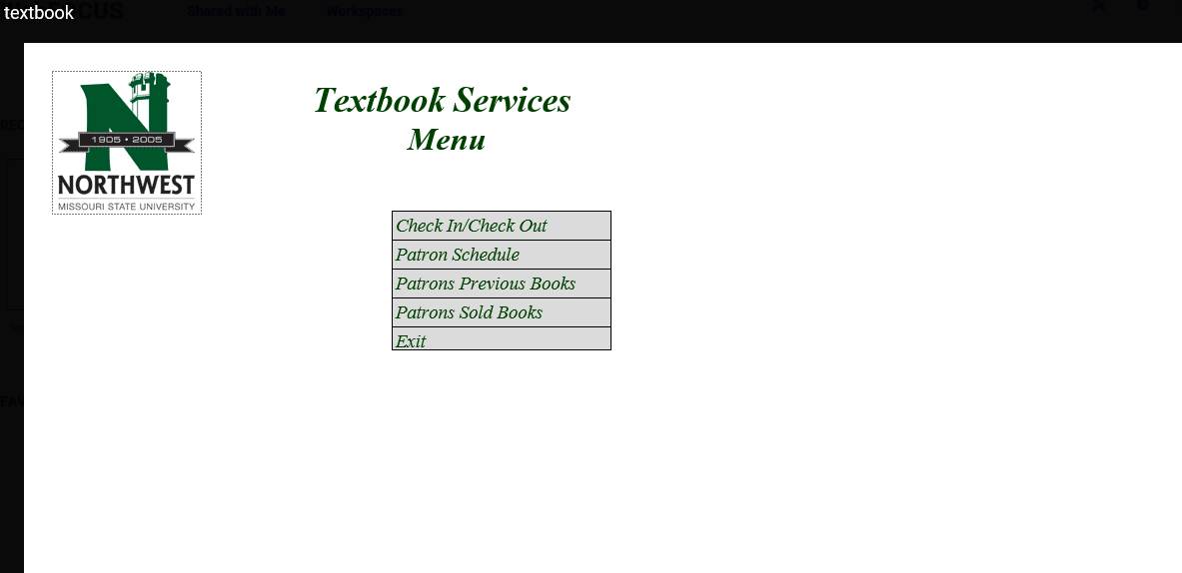

**This view is same as the Patron View of Supervisor View. It just has its menu Listed. The form view are same as the Supervisor Patorn submenu form view. Please refer to screenshots a-d of Submenu of Patron from Supervisor view above.**